Lab programs
1. Aim
To develop a Python program to represent the percentage distribution of student grades using a pie chart and a bar chart, and to identify the maximum and minimum number of students and the combined percentage of A and S grades.
2. Algorithm
- Start the program.
- Import the matplotlib.pyplot library.
- Store the grades and the number of students in lists.
- Calculate the total number of students and the percentage for each grade.
- Draw a pie chart to show the percentage distribution of grades.
- Draw a bar chart to show the number of students in each grade.
- Find the grade with the maximum and minimum number of students.
- Calculate the combined percentage of A and S grades.
- Display the results.
- Stop the program.
3. Procedure
- Open Google Colab at https://colab.research.google.com.
- Create a new notebook.
- Copy and paste the given Python program into a code cell.
- Click the Run button to execute the program.
- Observe the pie chart and bar chart generated by the program.
- Check the printed maximum, minimum, and combined percentage values.

4. Program:

import matplotlib.pyplot as plt

grades = ['F', 'E', 'D', 'C', 'B', 'A', 'S']
students = [3, 4, 5, 8, 9, 7, 4]

total = sum(students)
percentages = [n / total * 100 for n in students]

# Pie chart
plt.figure(figsize=(7, 6))
plt.pie(percentages, labels=grades, autopct='%1.1f%%', startangle=90)
plt.title("Percentage Distribution of Grades")
plt.legend(grades, title="Grades")
plt.show()

# Bar chart
plt.figure(figsize=(7, 5))
bars = plt.bar(grades, students, color='skyblue')
plt.xlabel("Grades")
plt.ylabel("Number of Students")
plt.title("Number of Students in Each Grade")
plt.bar_label(bars)
plt.legend(["Students"])
plt.show()

# Maximum and minimum
max_grade = grades[students.index(max(students))]
min_grade = grades[students.index(min(students))]

print("Maximum students:", max_grade, "-", max(students))
print("Minimum students:", min_grade, "-", min(students))

# Combined percentage of A and S
combined = (students[5] + students[6]) / total * 100
print("Percentage of A and S grades combined:", combined, "%")
output:
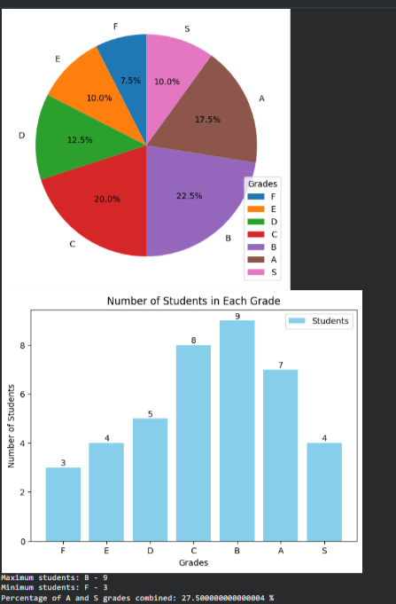
Result: The Python program was successfully executed to display the percentage distribution of grades using a pie chart and the number of students in each grade using a bar chart.
2. 1. Aim
To develop a semantic network using Python and the NetworkX library to represent relationships between entities such as Dog, Mammal, Animal, and Tommy.
2. Algorithm
- Start the program.
- Import the NetworkX library.
- Create a directed graph using nx.DiGraph().
- Add edges representing relationships between entities.
- Print the source entity, relationship, and target entity.
- Stop the program.
3. Procedure
- Open Google Colab at https://colab.research.google.com.
- Create a new notebook.
- Copy and paste the given Python program into a code cell.
- Click the Run button.
- Observe the output displayed below the code cell.
4. Program:
import networkx as nx

G = nx.DiGraph()

G.add_edge("Dog", "Mammal", relation="is-a")
G.add_edge("Mammal", "Animal", relation="is-a")
G.add_edge("Dog", "Tommy", relation="has-instance")

print("Source Entity -- Relationship -- Target Entity")

for source, target, data in G.edges(data=True):
print(source, "--", data["relation"], "-->", target) give aim,algorhim,proecudure and result

Output:
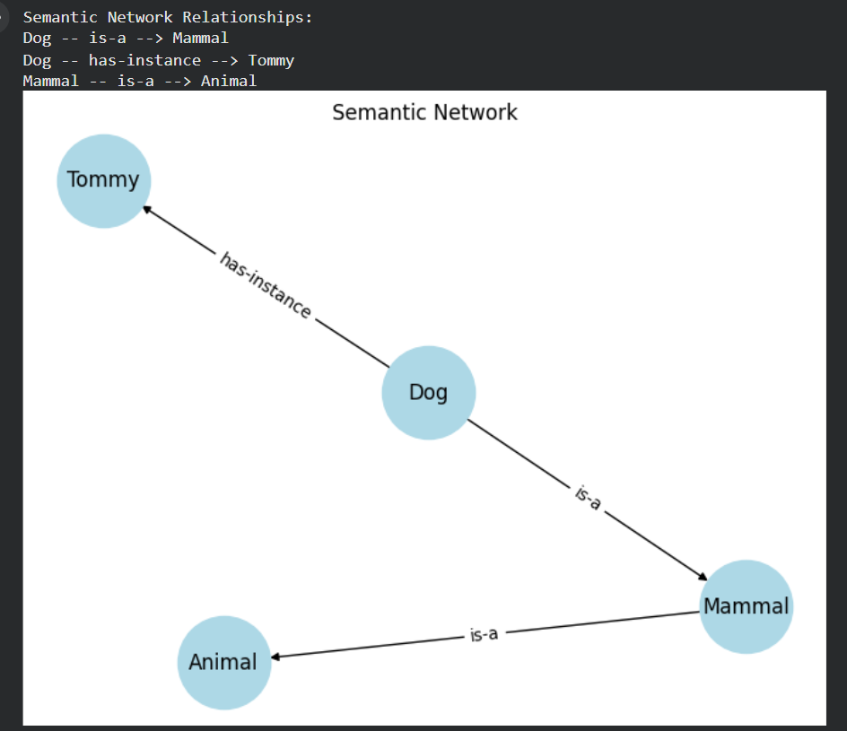
Result: The semantic network was successfully created using NetworkX, and the relationships between entities were displayed.
3. 1. Aim
To develop a Python program to represent vehicle information using a frame-based knowledge representation method.
2. Algorithm
- Start the program.
- Create a dictionary named vehicle.
- Store the vehicle details such as class, brand, fuel type, number of wheels, and color.
- Print the heading "Vehicle Frame".
- Use a for loop to access each slot and its value.
- Display the vehicle details.
- Stop the program.
3. Procedure
- Open Google Colab: https://colab.research.google.com.
- Create a new notebook.
- Copy and paste the given Python program into a code cell.
- Click the Run button.
- Observe the output displayed below the code.
Program:
vehicle = {
"class": "Vehicle",
"brand": "Toyota",
"fuel_type": "Petrol",
"wheels": 4,
"color": "White"
}

print("Vehicle Frame")

for slot, value in vehicle.items():
print(slot, ":", value)
give for this aim,algorthim ,procedure and result
Output:
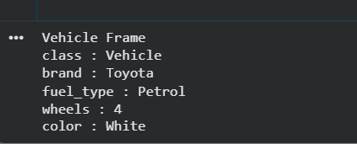
Result: The Python program was successfully executed to represent vehicle information using a frame-based knowledge representation method.

